Exercise 1: Mocking and Stubbing
Step 1: Create ExternalApi.java
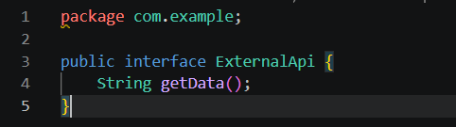

Step 2: Create MyService.java
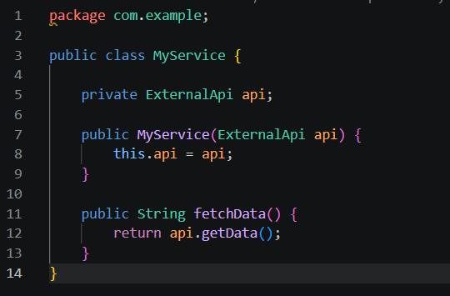
Step 3: Create MyServiceTest.java
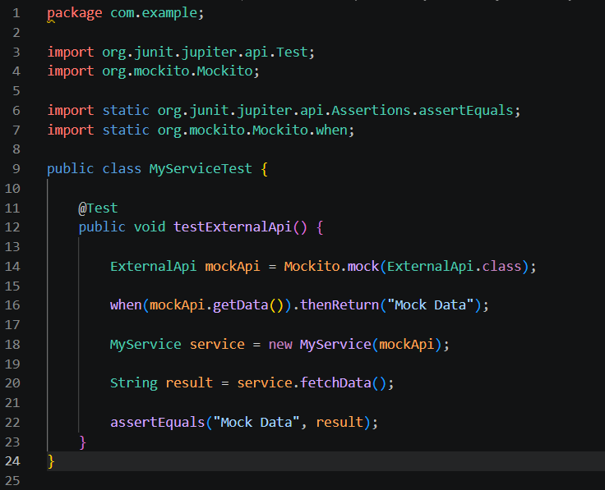

Step 4: Add Mockito dependency in pom.xml
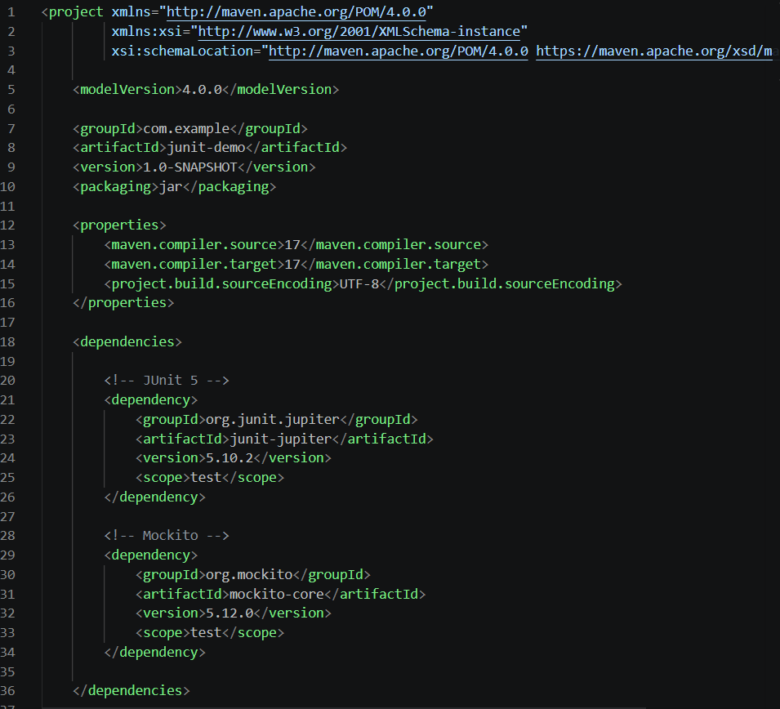
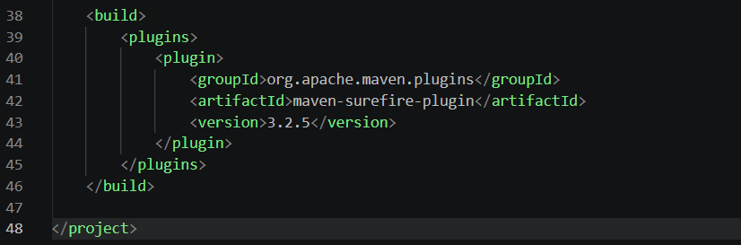
Run Command
mvn test -Dtest=MyServiceTest

Output
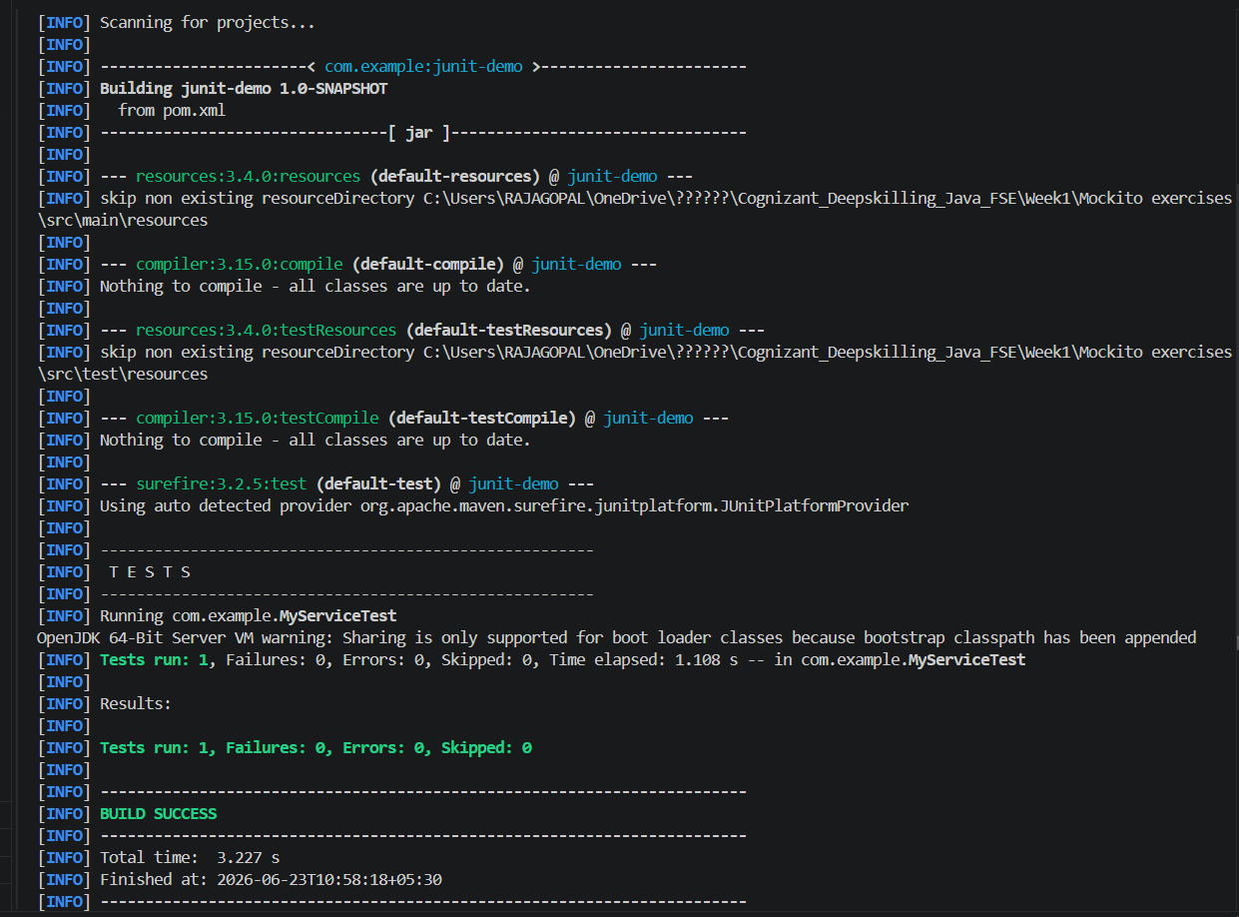
Result:
The external API was successfully mocked using Mockito. The getData() method was stubbed to return a predefined value ("Mock Data"). The test case executed successfully and the build completed with BUILD SUCCESS.

Exercise 2: Verifying Interactions
Step 1: Create mock object
ExternalApi mockApi = Mockito.mock(ExternalApi.class);
Step 2: Call service method
service.fetchData();

Step 3: Verify interaction
verify(mockApi).getData();
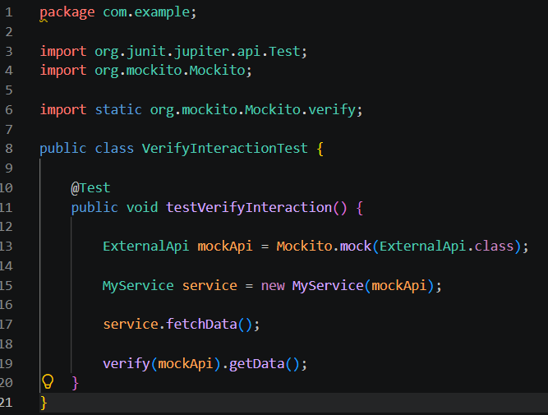

Run Command
mvn test -Dtest=VerifyInteractionTest
Output
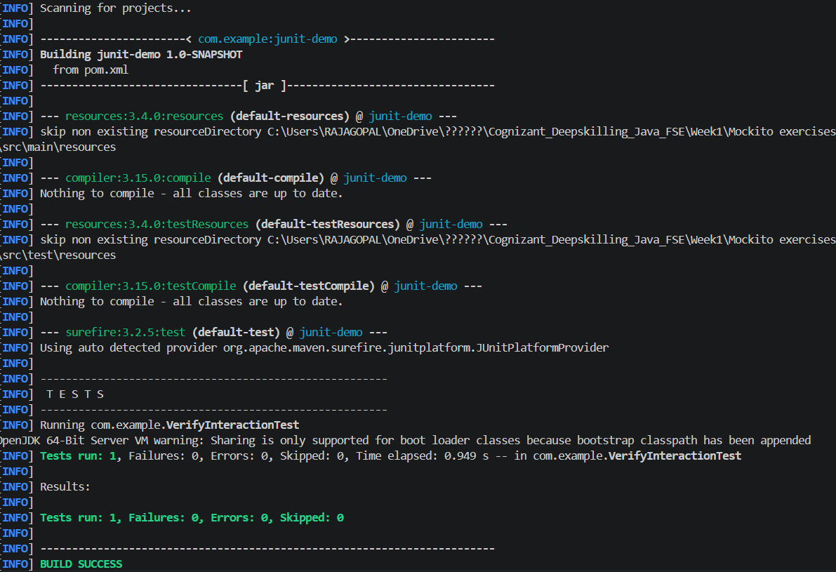
Result:
The interaction between MyService and ExternalApi was successfully verified using Mockito. The getData() method invocation was confirmed using verify().

